Dairy Farm Sustainability Award

2013 Nomination Form

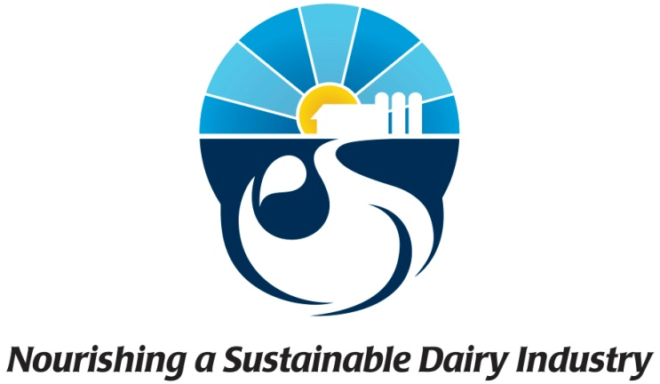
ELIGIBILITY:
To be eligible for this Award, an individual must:
- be a dairy farmer with quota holdings in Canada, and
- have a dairy operation with an up-to-date Environmental Farm Plan developed in accordance with applicable provincial programs.

The deadline for submissions is FRIDAY March 1, 2013.

HOW TO SUBMIT NOMINATIONS:
An individual may nominate him/herself or be nominated by a third party.

The nomination form must be accompanied by two letters of recommendation. Submission of photographs, maps or other documents to support the nomination is strongly encouraged. Please note that the nomination form and accompanying documents will not be returned. For additional information regarding the form or the award email Diane DOT Richer AT dfc-plc DOT ca

Instructions:
- All sections of the form must be completed. Incomplete applications will not be considered.
- Include photos, maps, newspaper clippings or other supporting materials with your application that will illustrate the responses that are written below.

Section 1: Farm background

  - Please use the following to describe the farm operation and history.
- Farm is owned by: since:
- Total number of cows:
- Number of lactating cows:
- Cattle breed:
- Amount of owned land:
- Amount of leased land:
- Type of manure storage:
- Number of employees:
- Other agricultural activities aside from dairy production:
(Optional) Briefly include any other information relevant to providing a historical and operational background of the farm: Click here to enter text.

1.2 Provide a short description of the ecology of the farm using the following:
- soil type:
- terrain:
- presence of water courses:
- amount of forested land:
- approximate average annual rainfall:
(Optional) Briefly discuss how this ecology impacts the farm and/or provide additional information on farm ecology: Click here to enter text.

1.3 Please indicate which of the following planning tools the farm uses. For those which it does not have, indicate why not (e.g. not required, not relevant, no woodlot to manage, etc.).
- Environmental Farm Plan
- Nutrient management plan
- Whole farm plan
- Woodlot management plan or FSC forest plan for harvest sustainability
- Wildlife habitat plan
- Farm succession plan
- Other

Section 2: Environmental sustainability
Evaluation criteria:
- On-farm practices have resulted in noticeable and measurable improvements in water quality or conservation, soil health, energy use, waste reduction, biodiversity, greenhouse gas reductions, or other environmental indicators.
- The farm has set environmental goals beyond regulatory requirements and continues to take active steps to achieve these goals.

2.1 In the following table, briefly indicate the farm’s management goals for environmental sustainability. Indicate what steps were taken, or are being taken currently, to reach these goals and specify what the results of the goals and/or actions have been on the farm. Where possible, provide quantitative results (e.g. $/ha saved on fertilizer; tonnes of greenhouse gases reduced; reduction of L water consumed; etc.). The categories below are provided as a guide; where a given category is not relevant, please leave it blank, and add as many additional categories as needed.

Category | Management goals | Steps taken | Results
Wildlife conservation and biodiversity
Manure management
Nutrient management
Soil health
Energy conservation or generation of renewable energy
Water quality
Water conservation
Waste reduction
Building construction
Air quality improvement (including odour)

2.2 Indicate how the above results were monitored and evaluated.
Click here to enter text.

2.3 (Optional) Provide any additional explanation and information regarding the environmental sustainability of the farm.
Click here to enter text.

Section 3: Financial viability
Evaluation criteria:
- Environmental practices are financially viable over the long term (i.e. either maintain or improve economic viability).

3.1 Describe how sustainability practices or projects affected the productivity and/or profitability of the dairy operation. For example, was productivity increased? Were costs reduced? Where possible, provide quantitative examples (e.g. were able to save $/ha on fertilizer application by implementing practice X).
Click here to enter text.

Section 4: Social impacts
Evaluation criteria:
- Animal health and welfare, food safety, community relations, or other societal benefit are considered on the farm.
- Working conditions are conducive to a safe and enjoyable workplace, and farm succession planning is in place.
- Promotion of on-farm practices has or can lead to improved reputation of the dairy industry.

4.1 Describe practices on the farm to maintain and improve animal health and welfare. Indicate where and how the Code of Practice for the Care and Handling of Dairy Cattle has been applied on the farm.
Click here to enter text.

4.2 Describe employee relations on the farm or actions taken to improve working conditions for employees. Include, if relevant, how employees are engaged in espousing the farm’s sustainability values (e.g. animal care, environment, etc.)
Click here to enter text.

4.3 Indicate the types of involvement the farm has within the local community (e.g. farm tours; presentations on sustainable practices; participation in promotional, advocacy or research activities related to sustainability).
Click here to enter text.

4.4 (Optional) Briefly explain any other aspect of the farm’s involvement with or benefit to the local community or general society.
Click here to enter text.

Section 5: Reproducibility
Evaluation criteria:
- The dairy producer(s) involved have demonstrated innovation and leadership.
- Practices are relevant to other operations and could be replicated on other farms.
- The farm works with agricultural or other professionals to improve environmental or social practices, and/or participates in research activities.

5.1 Could the sustainable practices on your farm replicated on other dairy farms? If so, what advice could you give to other farms trying to do so?
Click here to enter text.

5.2 For the sustainable practices described in the above sections, has the farm worked with agricultural or other professionals (e.g. agronomists, dairy nutritionists, university or Agriculture Canada researchers, water specialists, nature conservancies, etc.)? If so, describe the type of interaction and how these relationships benefited the farm.
Click here to enter text.

5.3 (Optional) Please provide any additional information that has not been provided above, which contributes to highlighting the sustainable practices undertaken on the nominee farm. For example: lessons learned, unanticipated benefits, meeting provincial quality awards, etc.
Click here to enter text.

Section 6: Letters of recommendation
With the nomination, provide two letters of recommendation from outside the nominee farm. At least one letter should be from an agricultural or environmental professional such as, but not limited to, a local agronomist, dairy nutritionist, crop advisor, member of a local sustainability organization, or other advisor to the sustainability practices undertaken at the farm. The second letter may be from a neighbour, farmer, community leader or organization, etc. The letters should support the leadership and innovation of the nominee towards sustainability, by, for example, discussing the operation’s environmental practices. Please ensure these letters are signed or else sent directly from the writer.
Section 7: Contact information

Nominee:

Name

Farm name

Mailing address (street, city, province, postal code)

Telephone

Fax

Email

Website

Nominated by: (leave blank if farm is self-nominated)

Name

Title

Organization

Mailing address (street, city, province, postal code)

Telephone

Fax

Email

Website

Confirmation and Agreement

A. Where the individual completing the nomination form is the nominee:
- By submitting a nomination form for this Award, I confirm that I meet the eligibility criteria for the Award and that I have read, understood and agree to be bound by the general rules of the Award.

B. Where the individual completing the nomination form is nominating an individual other than him/herself:
- By submitting a nomination form for this Award on behalf of another individual, I confirm that I have obtained the consent of that individual, which consent is enclosed with this nomination form, and which consent states:
“I understand that I am being nominated for the Award. I consent to the nomination and confirm that I meet the eligibility criteria for the Award and that I have read, understood and agree to be bound by the general rules of the Award.”

